**Customer Satisfaction for Restaurants Based on Parameters for Business Development and Revenues**

|  |  |  |
| --- | --- | --- |
| Mrs. Uma M (AsstProf.(Sr.G)) Department Of Software Engineering Srm University Chennai, T.N, India | Sourabh Agarwal Department Of Software Engineering, Srm University, Chennai, Tamil Nadu, India [sourabh.max01@gmail.com](mailto:sourabh.max01@gmail.com) | Mohit Ratnesh Department Of Software Engineering, Srm University, Chennai, Tamil Nadu, India [mohit.ratnesh@gmail.com](mailto:mohit.ratnesh@gmail.com) |

***Abstract*-** Customer Satisfaction is the main objective of any business to grow and develop in any positive way. Therefore this application is created in such manner that it will help the business owners to predict the requirements of the customer and meet the demands the make. This will not only help the customer to be happy but also the business owners to concentrate their focus on what are the things necessary and what not. This application is designed for restaurant owners to provide customer satisfaction using various parameters. The application is limitless for this kind of application for any field of technology.

**INTRODUCTION**

In the present scenario’s there are lots of restaurant coming to the market to provide the fooding services but due to huge increase in fooding industry there is sudden decrease in customers visits because of every time the customer moves to new restaurants to try new dishes while the older restaurants start loosing their customers. Also the new restaurant come with huge opening to lure customer then after a while starts decreasing their services which results in loosing the customer therefore to over come this kind of scenarios one most know the criteria to keep their customer happy therefore this application is created to take customers feedbacks and analyse them and predict wether the customer will come back or not. In future it will help restaurant to maintain their customer relationship and also customer to find best restaurant in this continuous growing market of restaurants.

**LITERATURE SURVEY**

The six factors impacting the customer satisfaction basing on the literature reviews and in-depth interviews with consumers. The questionnaire found that the restaurant property and customer interests and quality of the meal have significant correlation with customer satisfaction [1]. Classification models are developed using decision tree and neural network to determine underlying attributes of customer satisfaction. Generated rules are beneficial for managerial and practical implementation in fast-food industry. Decision tree and neural network yield more than 80% of predictive accuracy [2]. The literature shows that service quality is closely related to customer satisfaction and customer loyalty. Service quality is an important input to

customer satisfaction and trust as one of the important outcomes

of service quality models [3]. Decision trees classifiers are simple and prompt data classifiers as supervised learning means with the potential of generating comprehensible output, usually used in data mining to study the data and generate the tree and its rules that will be used to formulate predictions. One of the major challenges for knowledge discovery and data mining systems stands in developing their data analysis capability to discover out of the ordinary models in data [4].With the growth of Indian economy, incomes of individuals have also risen. With higher disposable income in their hands, people have adopted new lifestyle trends. One of such trends is visiting restaurants. Given the increase in the number of people visiting restaurants and with the demanding nature of such people, it is imperative for restaurateurs to understand the likes and dislikes of their customers [5]. This research constructs a scale to measure the perceived quality of Haidilao hot pot restaurant, and then evaluates the relationships among perceived quality, customer satisfaction and customer retention by the structural equation model and multiple regression analysis [6].When people waits for an extending time in a restaurant, the restaurant must take an appropriate action to recovery it to reduce consumers’ dissatisfaction and negative oral spreading in order to bring back consumers and reduce

loss of customers. The contingent behavior analysis (CBA) is used for establishing the revisit benefit of the restaurant waiting service, which is used for analyzing factors and benefits affecting people’s revisit demand under the service recovery and improvement plans “increase service quality” and

“improve restaurant facilities and add technical equipment” [7]. The evaluation of service quality is very important for fast food industry. This paper construct the service quality evaluation system of fast food industry based on the customer's point of view, and put forward the questionnaire of

service quality in Fast Food Restaurant (FFR). Through the investigation and analysis, a valuable target system of service quality in FFR was constructed [8].In order to reveal the effecting mechanism produced by expectation to service quality and customer satisfaction, we made the studies on the relationships between expectation, perceived service quality and customer satisfaction. Based on the attributes division of Kano’s model,

this paper built the structure model about the relationships of must-be attributes expectation, one-dimensional attributes expectation, attractive attributes expectation, perceived service quality and customer satisfaction, and made the

hypothesis [9].Recently in the restaurant businesses, it has become more difficult to design contents of dishes because customers’ preferences have become diverse. Leftover meals are good indicators to elucidate customers’ satisfaction and eating behaviors. This study examines what causes customers to leave food uneaten––particularly addressing their attributes,

motivations, and situations––by conducting interviews of customer groups and measuring their leftovers. Results show that leaving leftovers is significantly influenced by customers’ purposes, not by their attributes such as sex or age. Based on the results, this paper presents a discussion of flexible menu design [10]. WEKA is a popular machine learning workbench with a development life of nearly two decades. This article provides an overview of the factors that we believe to be important to its success. Rather than focussing on the software’s functionality, we review aspects of project management and historical development decisions that likely had an impact on the uptake of the project [11].

**DATA MINING**

Data mining, the extraction of hidden predictive information from large databases, is a powerful new technology with great potential to help companies focus on the most important information in their data warehouses. Data mining tools predict future trends and behaviors, allowing businesses to make proactive, knowledge-driven decisions. The automated, prospective analyses offered by data mining move beyond the analyses of past events provided by retrospective tools typical of decision support systems. Data mining tools can answer business questions that traditionally were too time consuming to resolve. It is helping us to predict whether the customer will come again to the restraints or not by taking parameters like price, rating, food rating, service rating to predict the outcome. We are using WEKA Tool to apply our machine learning to the datasets.

**ARCHITECTURE DIAGRAM**

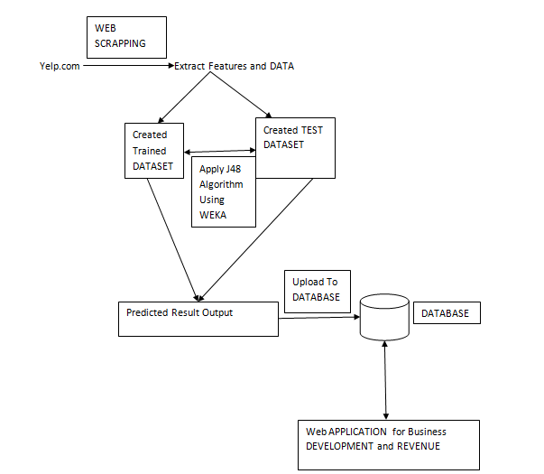

Fig: Architecture diagram for the restaurant based development system

First we are extracting features and data from the website by using web scrapping methodology in python.  
Then we are creating a Trained Dataset by using the gathered data and a Test Data to predict our required outcome.

We are applying J48 or Decision Tree and Decision Table algorithm by supplying the test dataset in the Weka Tool to predict the outcome.

Then the predicted dataset is get uploaded to the database from where the Admin of the organisation get the required data and statistics to perform Business Development and plan their Investments according to the data entries.

**MODULE DESCRIPTION**

1. **DATA PRE-PROCESSING**

**FEATURE EXTRACTION**

We used web scrapping a feature from python to gather different parameters used by the restaurants to get feedback and reviews from the customers.

Web scraping (web harvesting or web data extraction) is [data scraping](https://en.wikipedia.org/wiki/Data_scraping) used for [extracting data](https://en.wikipedia.org/wiki/Data_extraction) from [websites](https://en.wikipedia.org/wiki/Website). Web scraping software may access the World Wide Web directly using the [Hypertext Transfer Protocol](https://en.wikipedia.org/wiki/Hypertext_Transfer_Protocol), or through a web browser. While web scraping can be done manually by a software user, the term typically refers to automated processes implemented using a [bot](https://en.wikipedia.org/wiki/Internet_bot) or [web crawler](https://en.wikipedia.org/wiki/Web_crawler). It is a form of copying, in which specific data is gathered and copied from the web, typically into a central local database or spreadsheet, for later retrieval or analysis.

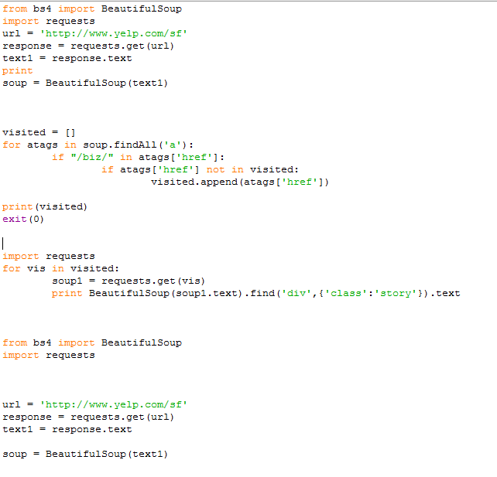

Fig: python code for web scrapping

**DATA COLLECTION**

During the extraction we collected different data provided by the users for the different restaurants and cleaned it as per the requirement of our project.

Data collection is the process of gathering and measuring information on targeted variables in an established systematic fashion, which then enables one to answer relevant questions and evaluate outcomes.

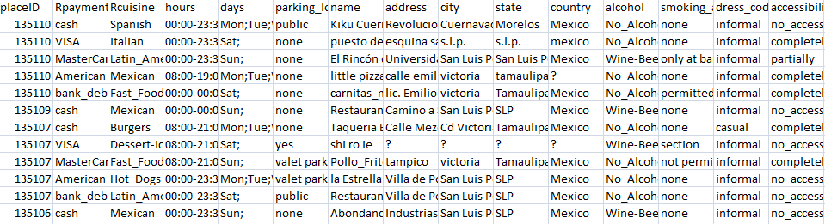

Fig: Datasets of Restaurants

**CLASSIFICATION**

We used J48 Algorithm and Decision Table Algorithm which is defined in WEKA Tool to predict and test the efficiency of the trained data set.

**J48 Algorithm**

It builds decision trees from a set of training data by using the concept of information entropy. The training data is a set of already classified samples. Each sample consists of a p-dimensional vector, where it represent attribute values or features of the sample, as well as the class in which it falls.

At each node of the tree, it chooses the attribute of the data that most effectively splits its set of samples into subsets enriched in one class or the other. The splitting criterion is the normalized information gain (difference in entropy). The attribute with the highest normalized information gain is chosen to make the decision.

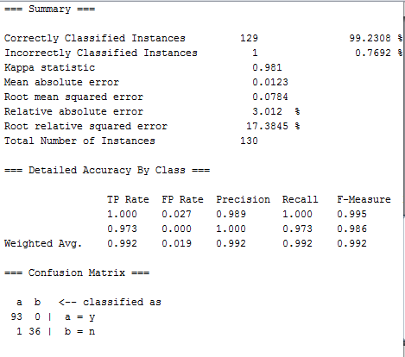

Fig: Summary for Decision tree

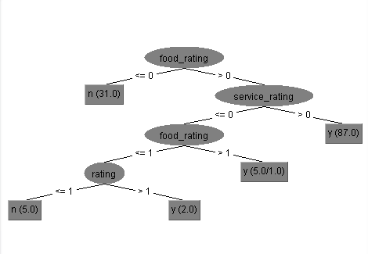

Fig: Decision Tree for dataset

**Decision Table**

Decision tables are a precise yet compact way to model complex rule sets and their corresponding actions.

Decision tables, like [flowcharts](https://en.wikipedia.org/wiki/Flowchart), [if-then-else](https://en.wikipedia.org/wiki/Conditional_(programming)), and [switch-case](https://en.wikipedia.org/wiki/Switch_statement) statements, associate conditions with actions to perform, but in many cases do so in a more elegant way.

Each decision corresponds to a variable, relation or predicate whose possible values are listed among the condition alternatives. Each action is a procedure or operation to perform, and the entries specify whether (or in what order) the action is to be performed for the set of condition alternatives the entry corresponds to.

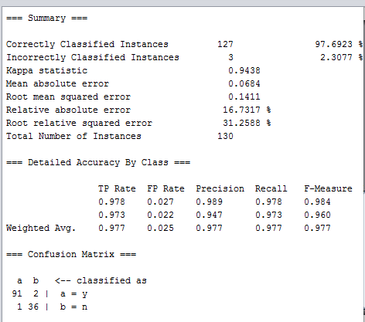

Fig : Summary for Decision table

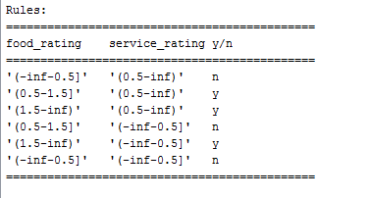

Fig: Rules for Decision Table

**APPLY MACHINE LEARNING**

Applied different machine learning like J48 and Decision Table to check which one is best suited for our project.

By applying these Algorithms we get different correctness of the prediction where we found out J48 is suiting best in our project so we went to apply J48 to our prediction model.

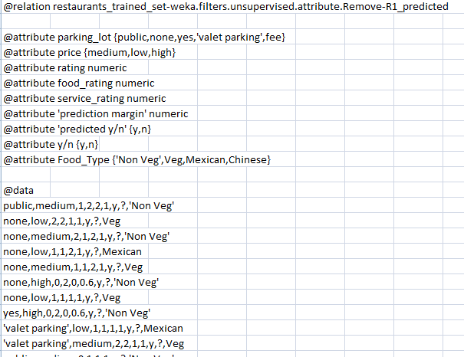

Fig: Predicted DataSet

**BUSINESS DEVELOPMENT MODEL**

Developed a Web Application from where the End User and Customers can able to access the required data which will help then to develop and plan their business strategies according to the data gathered.

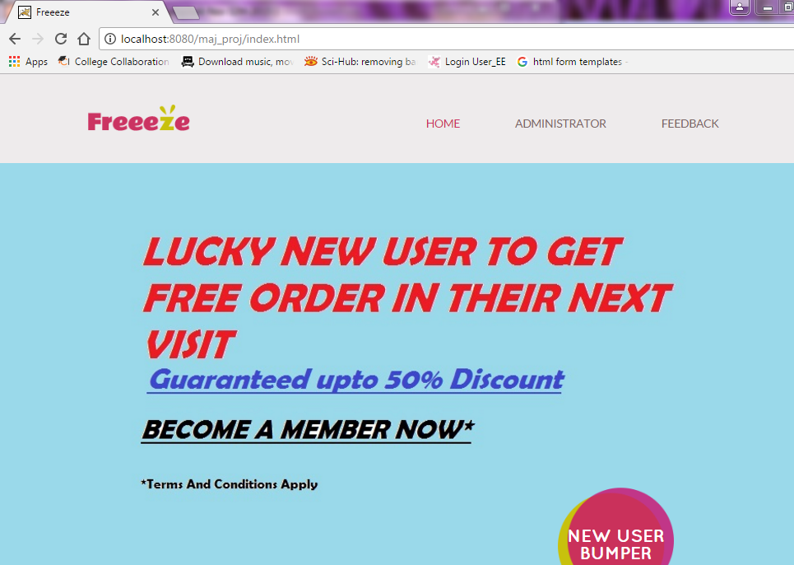

**REFERENCES**

1. Analysis on Food Customer Satisfaction, Gui Jie,Liu ying, Zhao Xiaoyan
2. DATA MINING FOR PREDICTING CUSTOMER SATISFACTION IN FAST-FOOD RESTAURANT, BAYU ADHI TAMA
3. Evaluation of customer satisfaction using the Quality Function Deployment, Marcela Pav]{ckova
4. Analysis and Predictions on Students’ Behavior Using Decision Trees in Weka Environment (Vasile Paul Bre_felean)
5. Role of Physical Environment (Dinescape Factors) Influencing Customers’ Revisiting Intention to Restaurants (Saravanan Mahalingam Bhawana Jain Mridula Sahay)
6. The Relationships Among Perceived Quality, Customer Satisfaction and Customer Retention: An Empirical Research on Haidilao Restaurant (Jing WANG ,Lijuan CHENG)
7. Evaluating the Benefits of Consumer Revisitation Intentions for Restaurants in Taiwan (Chung-Te, Szu-Chin, Yu-Sheng, Cheng-Te)
8. The Evaluation of Service Quality in Fast Food Industry (Yu Ding ,QiLan ZHAO, Hongzhi LIU)
9. Research on the Relationships among Expectation, Perceived Service Quality and Customer Satisfaction (XU Xian-ying)
10. Analysis of Eating Behavior in Restaurants Based on Leftover Food (Takeshi Shimmura)
11. WEKA—Experiences with a Java Open-Source Project (Remco R. Bouckaert, Eibe Frank, Mark A. Hall, Geoffrey Holmes, Bernhard Pfahringer , Peter Reutemann , Ian H.Witten)